MOETEN = have to of must in English.

**HAS TO** (bij he,she,it) **MUST (= meest streng)**

**HAD TO** (verleden tijd) > Must kan **NOOIT** in de verleden tijd <

Bij:

|  |  |
| --- | --- |
| Zekerheid:  Dit *moet* het goede restaurant zijn: This has to be the right restaurant. | **Je mag ook ‘must’ gebruiken**:  This must be the restaurant! |
| She has to be in here! | She must be in here! |
| She had to move  (verleden tijd) | This must have been the restaurant. |

|  |  |
| --- | --- |
| Noodzakelijkheid (obligation):  We *moeten* al deze boeken lezen voor het examen:  We have to read all these books for the exam | **Je mag ook ‘must’ gebruiken:**  You must read all these books for your exam |
| Dringend advies: You **have to** brush your teeth before bed. | She **must** finish her book before the exam. |

Negatieve vormen:

You **do not have to** eat that VS You **must not** eat that!

(je kan dit eten, maar het (je mag dat niet eten! –het

hoeft niet) is verboden)

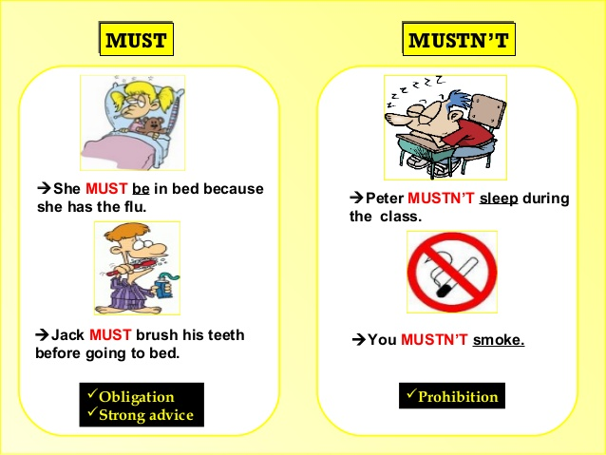

**Must, Have to 1**

1. New drivers  take a test in order to get a driver's license. They have no choice.  
  
2. A:  go to work today? B: No, I don't because it's Sunday.  
  
3. John  finish the report quickly because the deadline is today at 4 pm.  
  
4. A: Jennifer lost her passport.  get a new one? B: No, she ****. She found it in her purse.  
  
5. I'm sorry, Mom. I  call you back later. My cell phone battery is dying.  
  
6. Canadians  pay taxes every year. It's the law.  
  
7. Sasha   email her homework to her teacher because she forgot to take it to class yesterday.  
  
8. A: Does Joseph  study very much tonight? B: No, he doesn't. He reviewed a lot last night and he understood everything well.  
  
9. Barbara  go to the supermarket because she doesn't have enough food for dinner.

**Answers on the next page!**

**MUST, HAVE TO 1**

1. New drivers **must** take a test in order to get a driver's license. They have no choice.  
2. A: **do you have to** go to work today? B: No, I don't because it's Sunday.  
3. John **has got to** finish the report quickly because the deadline is today at 4 pm.  
4. A: Jennifer lost her passport. **Did/does she have to** get a new one? B: No, she **didn't/doesn’t**. She found it in her purse.  
5. I'm sorry, Mom. I **have to** call you back later. My cell phone battery is dying.  
6. Canadians **have (got) to/must** pay taxes every year. It's the law.  
7. Sasha **had to** email her homework to her teacher because she forgot to take it to class yesterday.  
8. A: Does Joseph **have to** study very much tonight? B: No, he doesn't. He reviewed a lot last night and he understood everything well.  
9. Barbara **has to** go to the supermarket because she doesn't have enough food for dinner.